**Education**

June 2012 B.S., Mechanical Engineering • California Institute of Technology • Pasadena, CA

GPA: 3.7 • Graduated with Honors

**Work Experience**

July 2012 – Present Robotics Engineer • Electroimpact • Mukilteo, WA

Projects:

* + - * Programming
        + Robot Numerical Controller to manage robot motion and sensor logic, in C++.
        + GUI to allow a person to easily control the robot, in C++.
      * Data analysis
        + Developed a new model and implemented it in real time to improve robot accuracy by a factor of two.
        + Collect and analyze data to reduce positional error from a robotic arm manipulator.

2011-2012 Teaching Assistant • Caltech • Pasadena, CA

* Lectured to Mechanical Engineering students.
* Managed machine shop.

Summer 2010, 2011 Research Fellow • Caltech • Pasadena, CA

Project: Fluids Research

Funding: Summer Undergraduate Research Fellowship

Advisors: John Dabiri, Ph.D. and Beverly McKean, Ph.D.

* Designed, simulated, and fabricated parts for and tested a novel vertical axis wind turbine.
* Designed and performed fluids simulations and wind tunnel tests.

Summer 2009 Intern • Sezmi • Belmont, CA

* Programmed DVR-like device.
* Demoed DVR device to investors for this tech startup.

**Publications**

Brad Saund, Russ DeVlieg (2013, Sep 25). High Accuracy Articulated Robots with CNC Control Systems. Paper presented at Society of Aeronautical Engineers: AeroTech, Montreal.

**Service**

2013- Present Volunteer Mentor • FIRST LEGO League • Seattle, WA

* Mentor a team of middle school students in the practice and theory of robotics using the Mindstorms EV3 LEGO set.

2011-2012 President in student government • Caltech • Pasadena, CA

* Advocated for undergraduate student welfare.
* Worked closely with Deans, Vice President, and Housing.

**Personal Projects**

July 2014 Kinect v2 for Windows Hack-a-thon • Microsoft • Redmond, WA

* Team placed 2nd in contest.
* In 28 hours learned Kinect system and coded a playable game in C#.
* See video footage of game play here: <https://www.youtube.com/watch?v=9F3NZILk5Ko>
* Screen shot of game play:

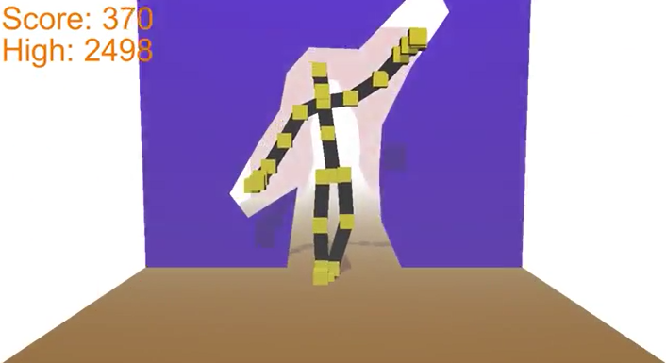

2012 Robotic Vision • Caltech • Pasadena, CA

* Used input from wheel odemetry, a camera, and a laser scanner to Simultaneously Localized And Map (SLAM) a vehicle in an obstacle field, in MATLAB.
* Detected a reference image in another picture and found the image’s transform. Example image below:

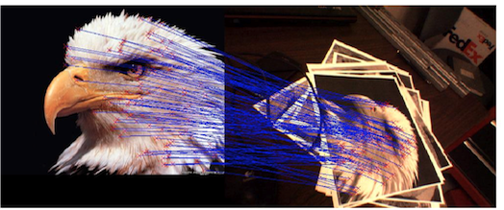

* Determined motion between frames of a video camera. Example image below:

